The 7-inch multi-touch screen for ODROID-C1+ gives users the ability to create all-in-one, integrated projects such as tablets, game consoles, infotainment systems and embedded projects. The 800 x 480 display connects via HDMI link board and micro-USB link board which handle power and signal. Just connect a DC plug in to the DC-jack on C1+ and you are ready to play if you install the latest OS update.
Touchscreen drivers with support for 5touch-points and proper drivers are integrated in the latest Ubuntu and Android OS image. Screen resolution must be configuredto WVGA (800x400) and enable the DVI option on the “vout” parameter by editing the boot.ini file.
This screen is designed for ODROID-C1+. You can attach the C1+ board on the back side of LCD screen and it can be a fully integrated system. It works with the old C1 board if you use a micro-HDMI cable and a micro-USB cable.
The 7inch HDMI LCD comes with a HDMI link board, a micro-USB link board, three 8mm PCB supporters, 6 screws. The price is only US$55. You can make a standalone embedded project with this affordable display device.
This screen also works with Android OS C1+. But you need to use the release version 2.0 or higher to use the touch screen.

Assembly guide for C1+
Case #1: Mount the C1+ board on the LCD unit with 3pcs of 8mm PCB supporters. HDMI link board and micro-USB link board are used for interface and power supply.

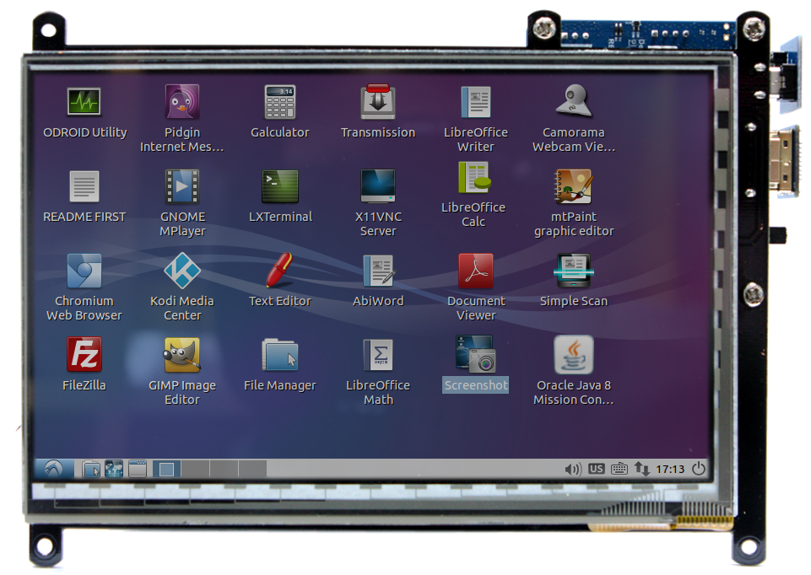

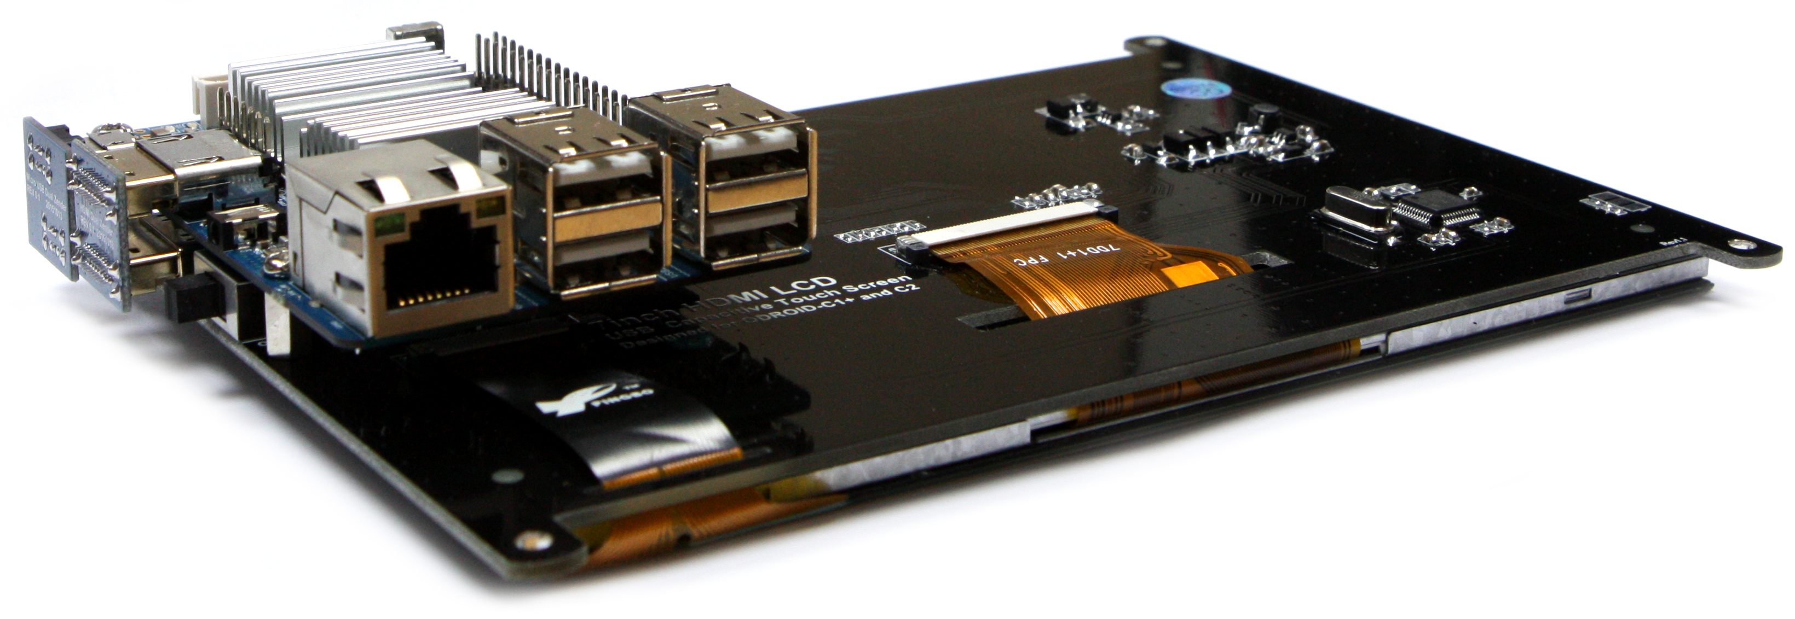
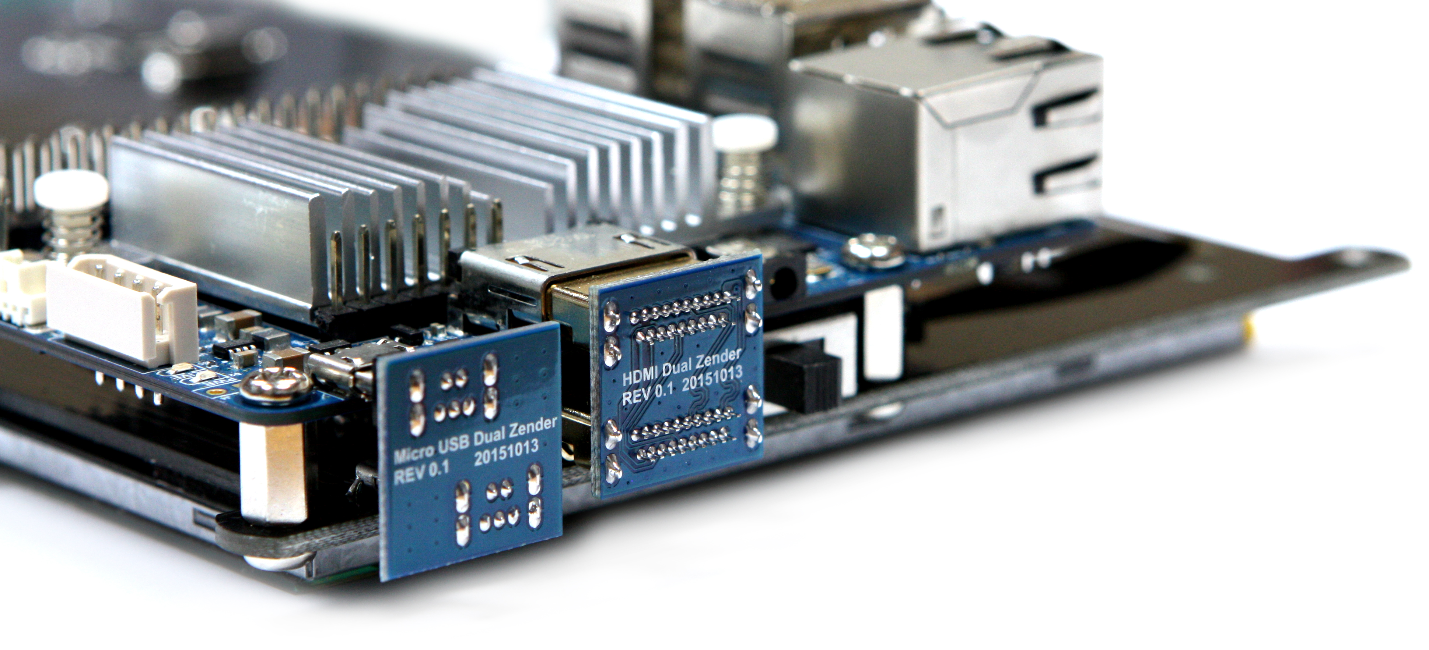

Case #2: Micro-to-micro USB cable and flexible flat HDMI cable can be used too. 35cm cable kit is sold separately.
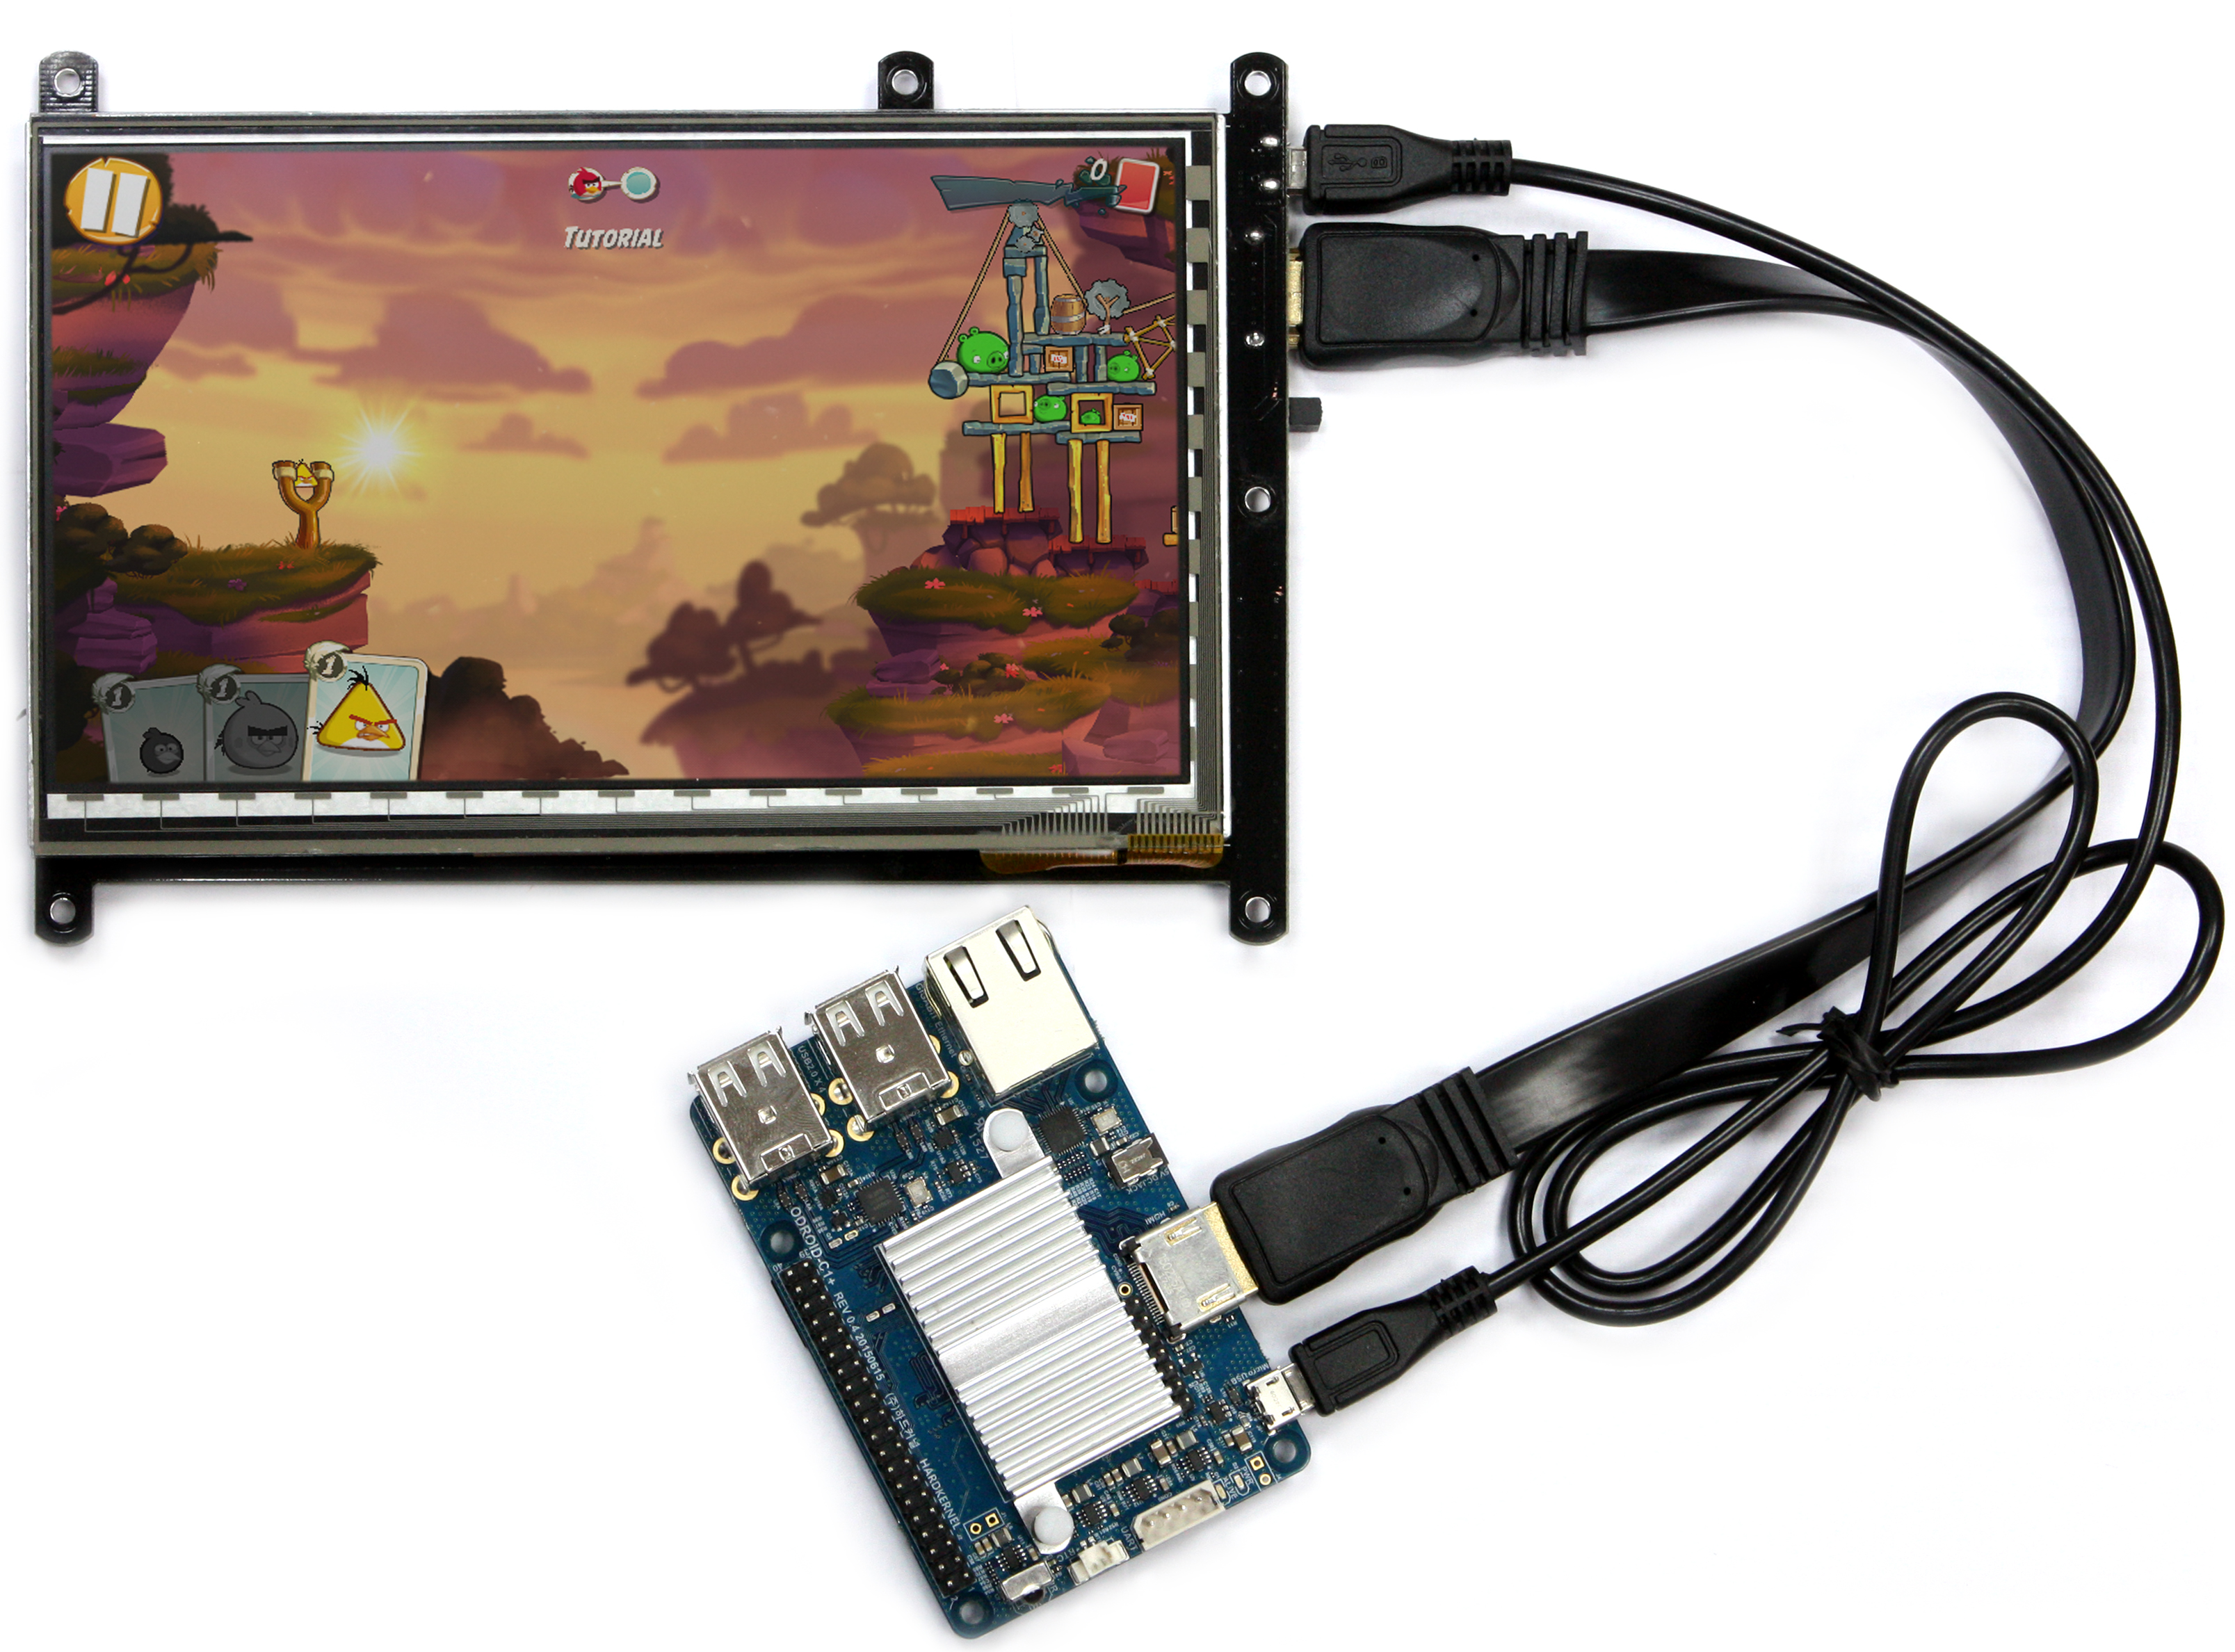

The old C1 model is also possible.
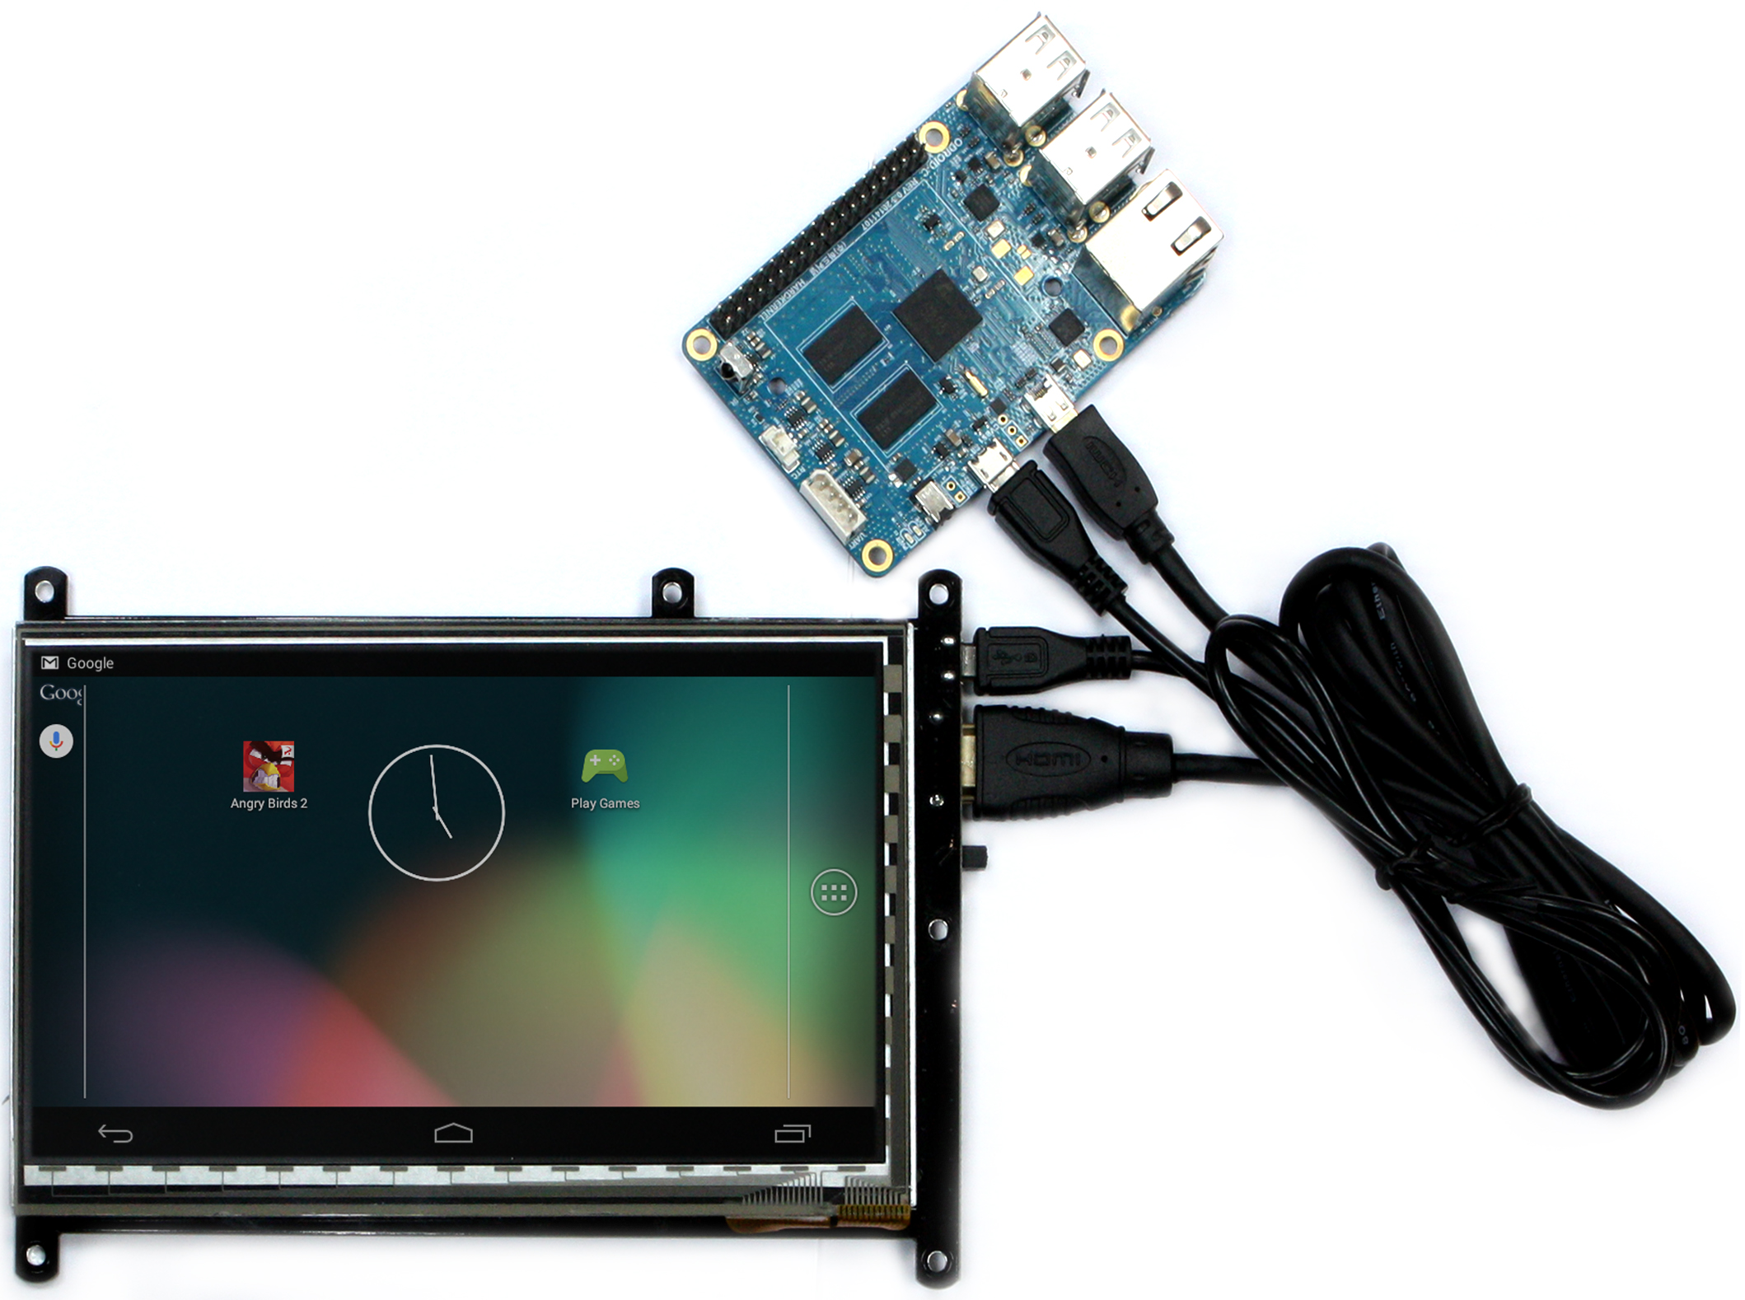

Specification
- 7inch TFT-LCD
- Screen Resolution: 800 x 480 pixels
- 5 finger capacitive touch input
- Power consumption : 600mA /5Volt
- Back-light on/off slide switch
- Viewing angle (in degree): Left 70, Right 70, Up 50, Down 70
- Screen Dimensions: 172.9 mm x 124.3 mm x 15 mm (including switch and connectors)
- Viewable screen size: 153.6 mm x 86.64 mm (Active area)

Block diagram
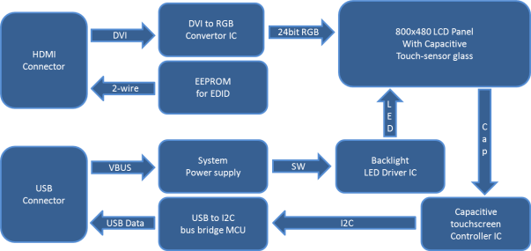* This product is developed by our partner company and we can’t release the schematics.

Physical dimension (rear side view)
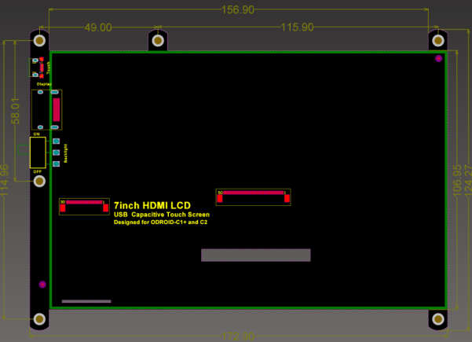

To use the touchscreen on Linux system, the Kernel version must be 3.10.80-128 or higher.
Also don’t forget to configure the boot.ini file like this for 800x480 resolution and DVI output mode. Otherwise, your screen will not work properly.

ODROIDC-UBOOT-CONFIG

# Possible screen resolutions
# Uncomment only a single Line! The line with setenv written.
# At least one mode must be selected.

# setenv m "vga" # 640x480
# setenv m "480p" # 720x480
# setenv m "576p" # 720x576
setenv m "800x480p60hz" # 800x480
# setenv m "800x600p60hz" # 800x600
# setenv m "1024x600p60hz" # 1024x600
# setenv m "1024x768p60hz" # 1024x768
# setenv m "1360x768p60hz" # 1360x768
# setenv m "1440x900p60hz" # 1440x900
# setenv m "1600x900p60hz" # 1600x900
# setenv m "1680x1050p60hz" # 1680x1050
# setenv m "720p" # 720p 1280x720
# setenv m "800p" # 1280x800
# setenv m "sxga" # 1280x1024
# setenv m "1080i50hz" # 1080I@50Hz
# setenv m "1080p24hz" # 1080P@24Hz
# setenv m "1080p50hz" # 1080P@50Hz
# setenv m "1080p" # 1080P@60Hz
# setenv m "1920x1200" # 1920x1200

# HDMI DVI Mode Configuration
# setenvvout_mode "hdmi"
setenvvout_mode "dvi"
# setenvvout_mode "vga"

Chromium browser supports the multi-touch pinch-zoom gesture.
So you can enjoy the zoom in and out like a smartphone.
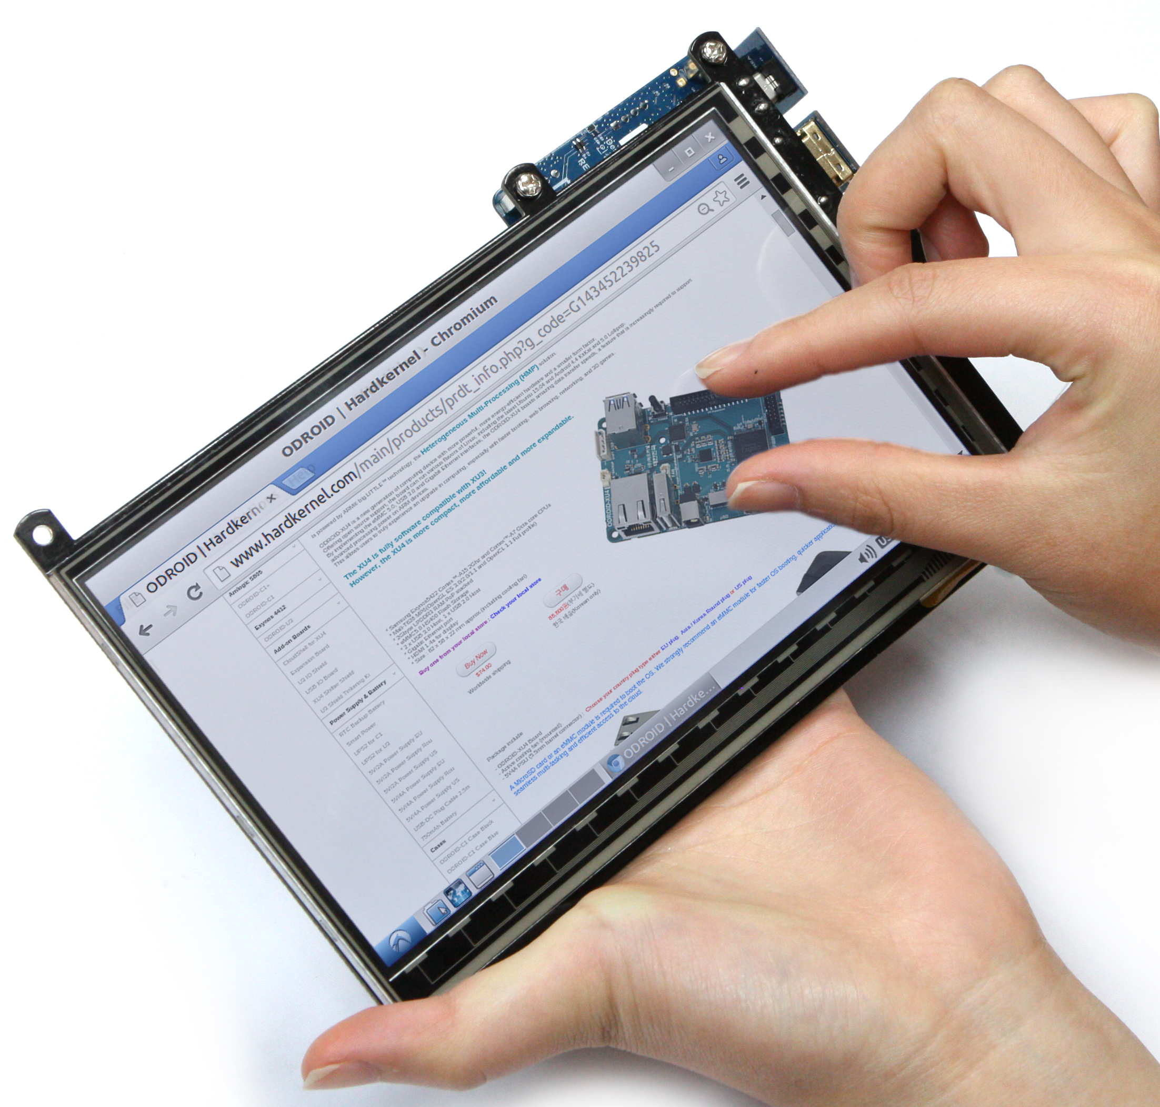
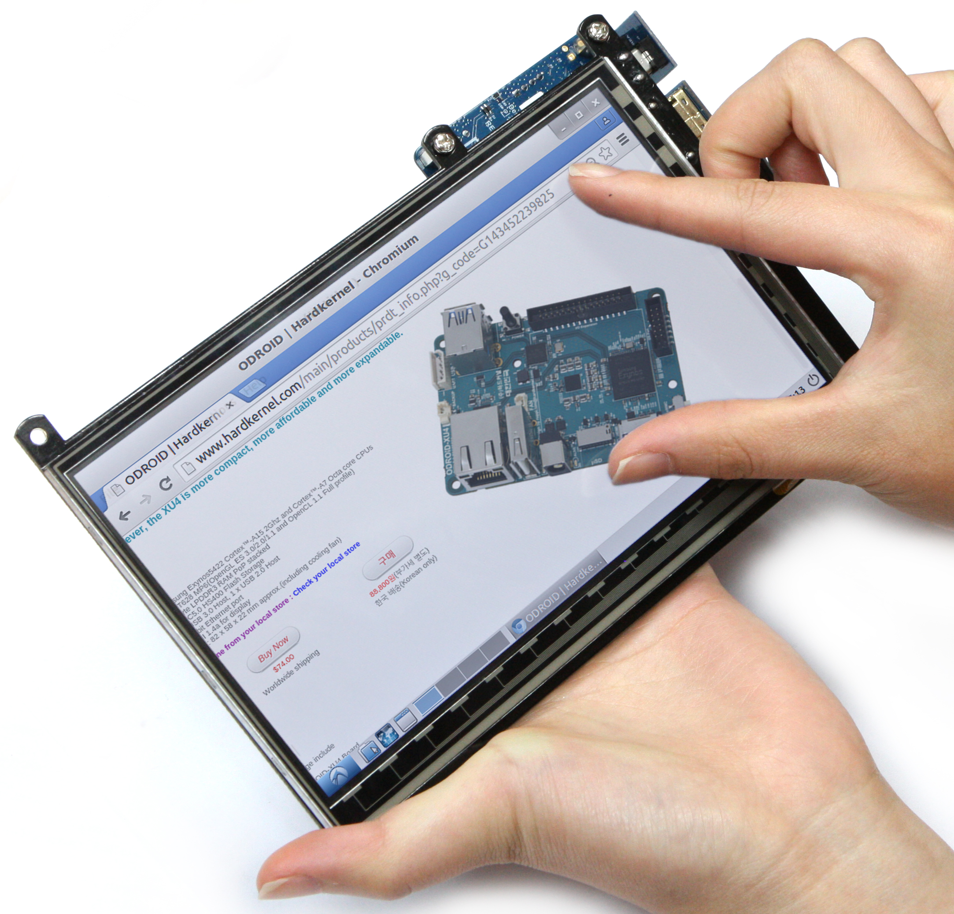

The 7-inch HDMI LCD doesn’t work with ODROID-XU4/3.
We will try to develop a new HDMI PHY driver to support this display for ODROID-XU4. Before we have a working display driver, do not purchase this product.

